.com
Chapter 9 Understanding Our Soul
Bible Class Handout Week 2

Today’s Date: _______________ My Name: ________________________________

Section 4 – The Search Engine (25:22)

- At the same time our mind is processing every entry in our current event file, it is conducting the following searches of our memory or knowledge files.

  - Have I ever ___________________________ anything like this before?

  - Have I ever _________________ anything like this before?

  - Have I ever _____________________________ anything like this before?

  - Have I ever _________________ anything like this before?

  - Have I ever _________________ anything like this before?

  - Have I ever _________________ this way about an event before?

  - Have my ___________________ ever registered like this before?

  - Have I ever _________________ before what I am contemplating

___________________ now?

- If yes to any of these questions, the mind quickly scans the _________________

overall __________________ of that memory file.

- If yes to any of these questions, the mind considers those files in determining or

plotting our next ______________ or course of ___________________ for the current event.

- A fully _____________________ memory file will have a virtual “Cover Sheet.”

- To fully __________________ a memory file requires that you ______________ it at least once after the event to finalize it.

- Most event files are finalized in our _________________.

- Incomplete files are then worked on in our ______________________________,

or ___________________ for later.

- The files that get shelved are usually those with __________________ emotions registering in the red zone.

- Every processed file a Christian carries should have these conclusions:

  - What did my ____________________ mind think about the event?

  - What did my ____________________ mind think about the event?

  - What __________________ emotions did I feel in this event?

  - What __________________ emotions did I feel in this event?

  - What were my responses in and because of this event? What were my ____________________ and ________________?

- My responses in every event must always be analyzed with these questions.

  - Were my responses pleasing to the _________________ or the

__________________?

  - What was the __________________ of my actions or words?

  - Were my responses the right thing according to the _______________

____________________? If ___________, then what should I have done or said?

  - How do I feel emotionally, both ______________ and _______________, about what I did?

  - Are these __________________________ actions for the future?

- The quickness that everyone is able to search and analyze their files,

Psychiatrists call that the individual’s ____________________ speed.

- It is important to process ______________ file of ________________ event, and store your conclusions at the front of that event file.

- Unprocessed memory files can put you — and keep you — in a perpetual state

of ___________________________.

- It is possible, even for Christians, to be attacked by a “spirit of confusion,”

because our soul is not yet totally _______________________.

- The Biblical deliverance formula is found in this scripture: __________________

- The three steps of the deliverance formula are:

  - ____________________ to God

  - ____________________ the devil

  - _________________________ to God

- Healthy memories are established by coming to __________________ and

_________________ “understanding” about every event in life.

Section 5 – The Three Cognitive Functions of the Mind (24:03)

- God pre-programs the subconscious functions of the human brain to

__________________ or ___________________ human life.

- 2 Corinthians 10:3–6 teaches us about spiritual _________________, and more

specifically, where spiritual ______________________ occur.

- According to 2 Corinthians 10:3–6, the three cognitive functions of the conscious mind are:

  - ____________________

  - ____________________

  - ____________________

- Knowledge is the _________________ and ___________________ of data from

our five senses, in the ______________________ memory files.

- Thoughts are cognitive _________________, conclusions, or _______________
which we make based on data we have received.

- Every decision or thought we think is always based on ___________________ information or data.

- The ability to perform deductive _________________, and reach

__________________ without having all the data sets mankind apart from the rest of God’s creations.

- Imaginations are _________________ thoughts.

- Every building or house we live in or work in, as well as every invention had to

start as someone’s _______________________.

- Our _____________ and ____________________ cannot tell the difference between imaginations and reality.

- Fill in the boxes on this chart.
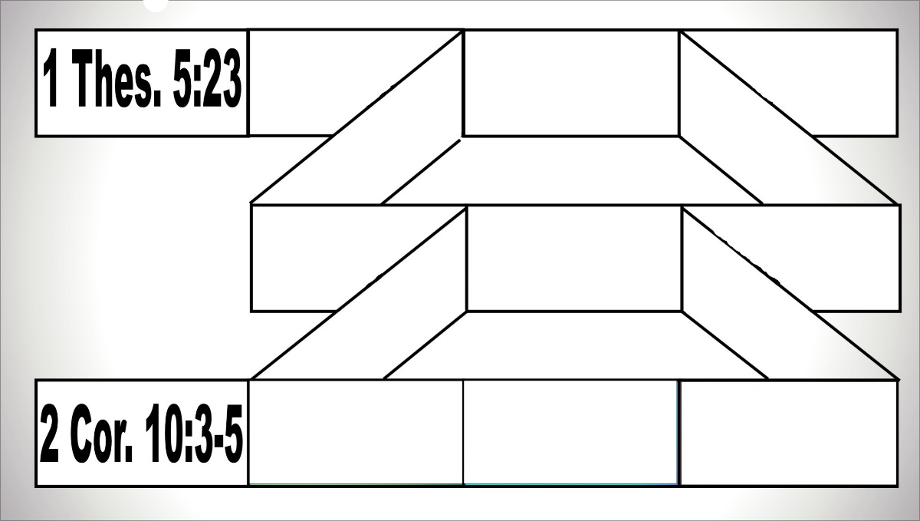

Discussion Questions

It is not anticipated that you will have time for group discussions this week, but if you do;

- The leader should read this scripture, then each person takes turns expressing how to bring your thoughts into obedience.

3For though we walk in the flesh, we do not war after the flesh:
4(For the weapons of our warfare are not carnal, but mighty through God to the pulling down of strong holds;)
5Casting down imaginations, and every high thing that exalteth itself against the knowledge of God, and bringing into captivity every thought to the obedience of Christ; 2 Corinthians 10:3-5 (KJV)

