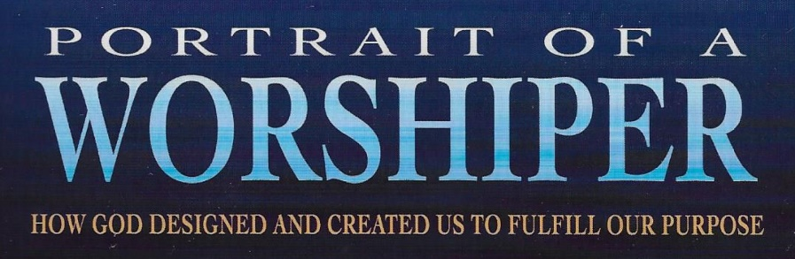
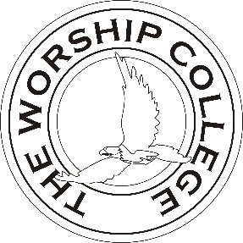.com
Chapter 9 Understanding Our Soul
Bible Class Handout Demo

Today’s Date: _______________ My Name: ________________________________

The Will Is Chairman of the Board (11:50)

- A chairman of the board only votes when there is a __________.

- Name the members of our board

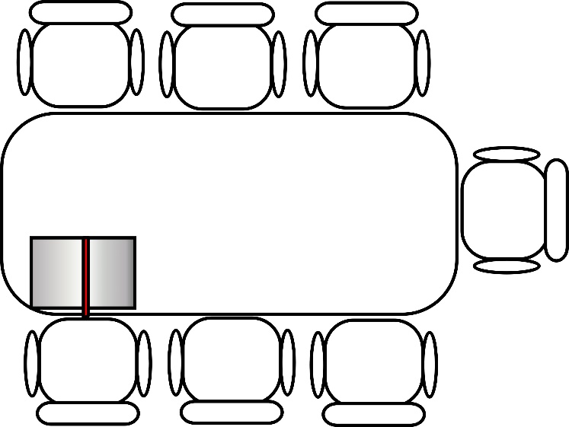

- Which two members together only get one vote? _________________ and

____________________.

- Who is the special guest at a Christian’s board table? ____________________.

- The special voting privileges of this guest are:

  - It can cast more than ________________ vote.

  - It cannot cast the _______________________________ vote.

- Any board member can suggest a course of action for our being, and call for a

______________________.

- What scripture says that the body has NOTHING to say when it comes to worship?
____________________________

- What scripture tells us to pray and worship God by “lifting holy hands?”

______________________________

Discussion Questions

- The leader should read this scripture, then each person takes turns expressing what it means to offer their body as a living sacrifice to God in their worship.

Therefore, I urge you, brothers and sisters, in view of God’s mercy, to offer your bodies as a living sacrifice, holy and pleasing to God—this is your true and proper worship. Romans 12:1 (NIV)

- The leader should read this scripture, then each person takes turns expressing why does God want us to lift our hands when we pray and worship Him?

In every place of worship, I want men to pray with holy hands lifted up to God, free from anger and controversy. 1 Timothy 2:8 (NLT)

