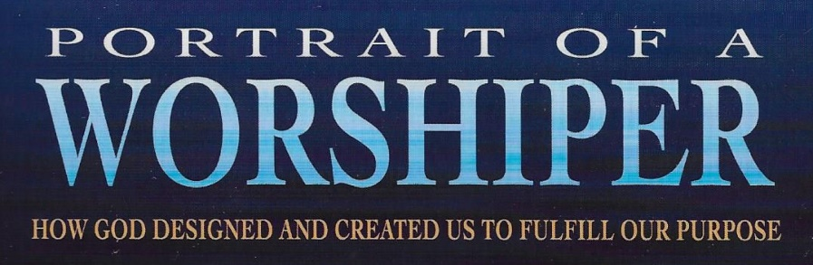
.com
Chapter 9 Understanding Our Soul
Bible Class Handout Week 1

Today’s Date: _______________ My Name: ________________________________

Section 1 – Natural Understanding (19:05)

- 1 Thessalonians 5:23 tells us we are made of these three parts:
- The soul is made up of these three parts:

- All three parts of our soul are processed in our _______________.

- For every event or experience we have in our lives, our brain creates a _______.

- While we are going through an experience, our brains will keep every _________

- In the middle of an experience, it is impossible to fully ___________________ it.

- Experiences in life are ___________________.

- The natural data we receive in every experience comes from our ___________

_______________.

- These are
- For every data entry we make, we ask these three questions about it.

  - What do we ________________?

  - What do we _________________________?

  - What will we ____________?

- Natural Understanding is arrived at by processing the data received from our

______________________.with the three parts of our _______________.

- Spiritual Understanding is gained by processing the data received from “the

_____________________________with the three parts of our ______________.

Section 2 – What Are Our Emotions? (6:53)

- The way we stay in touch with the physical part of our being is through our five

senses transmitting data to the brain through our _________________________.

- The way we stay in touch with both our soul, and Spirit, is through our

_____________________.

- We call the emotions the ________________________.

- Think of the emotions as ___________________.

- Each meter reports on a different ____________________________.

- Each meter contributes to the overall category of ____________________.

Section 3 – The Will Is Chairman of the Board (11:50)

- A chairman of the board only votes when there is a __________.

- Name the members of our board

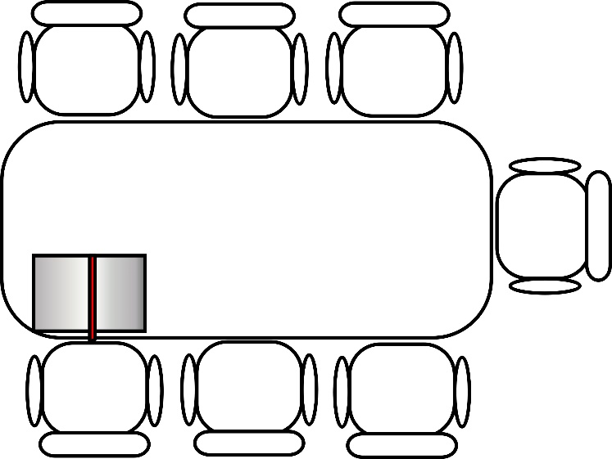

- Which two members together only get one vote? _________________ and

____________________.

- Who is the special guest at a Christian’s board table? ____________________.

- The special voting privileges of this guest are:

  - It can cast more than ________________ vote.

  - It cannot cast the _______________________________ vote.

- Any board member can suggest a course of action for our being, and call for a

______________________.

- What scripture says that the body has NOTHING to say when it comes to worship?
____________________________

- What scripture tells us to pray and worship God by “lifting holy hands?”

______________________________

Discussion Questions

- The leader should read this scripture, then have each person take a turn expressing why Paul prayed in this verse for all three parts of our being.

Now may the God of peace Himself sanctify you completely; and may your whole spirit, soul, and body be preserved blameless at the coming of our Lord Jesus Christ. 1 Thessalonians 5:23 (NKJV)

- The leader should read this scripture, then each person takes turns expressing what it means to offer their body as a living sacrifice to God in their worship.

Therefore, I urge you, brothers and sisters, in view of God’s mercy, to offer your bodies as a living sacrifice, holy and pleasing to God—this is your true and proper worship. Romans 12:1 (NIV)

- The leader should read this scripture, then each person takes turns expressing why does God want us to lift our hands when we pray and worship Him?

In every place of worship, I want men to pray with holy hands lifted up to God, free from anger and controversy. 1 Timothy 2:8 (NLT)

