.com
Chapter 9 Understanding Our Soul
Bible Class Handout Week 8

Today’s Date: _______________ My Name: ________________________________

Section 16 – Emotions of Pleasure as Emotions of Warning (7:47)

- What determines if an emotion will be a warning to us, or an indication of true

Godly pleasure, is the ___________________ of Godly truth.

- We needs to examine our emotions according to Godly _______________.

- A Christian man’s _____________ or _____________ may register love and joy emotions when he thinks about another woman other than his wife; however, this

man’s ________________ will register high readings of fear and caution in his emotions.

- The combination of love and fear in his emotions should produce the warning

necessary for ___________________________________.

- The Word of Truth will establish ______________________ in this situation, if

the man seeks and accepts it without ____________________.

- A marriage vow is a ____________________, which is binding. It has nothing to

do with the way you _______________.

- Feelings follow commitment or _______________. Actions should never follow

__________________!

- When the “warning lights” start to flash, they indicate something is

________________ and needs to be fixed.

Section 17 – The Will Is the Internal Switch (19:25)

- Our emotions can either indicate the state of our _______________ or the state

of our ________________.

- It is by spending time in the ______________ of God that causes us to discern the difference between our spirit and our soul.

- To the degree that we have been taught by the ___________________ and

________________ of Truth is the degree that we will discern the difference

between our soul and ___________________.

- Our spirit and soul use the same emotional ____________________ to indicate the state of our being on both levels.

- The soul and the spirit cannot ________________ the meters at the same time.

- By an act of our ______________, we can switch our meters to receive data from either our soul or our spirit.

- What causes our ________________ to experience joy, will not be what causes our spirit to experience joy.

- When our meters pick up what is happening in our ________________, they are

actually picking up on what is taking place in _______________ heart.

- In 2 Corinthians 11:1 Paul said “I am jealous over you.” This was not natural

jealousy Paul was feeling—it was “_________________ jealousy,”

- The fear Paul mentioned in that scripture was also a ______________________ concern for the Corinthians.

- Hebrews 4:15 tells us Jesus was tempted as we are, yet without ____________.

- Jesus got mad, yet in it He did not sin because it was it was _______________ anger.

- His actions were in defense of _________________________, not the desires of the flesh.

- The only way to make sure we do not sin with anger is to ___________________ the experience file containing the anger before the day is out.

- Don’t leave anger files to be processed another day, even if the anger is

Indicating the state of our ________________.

- When the emotional indicator “anger ” starts registering, it is like a ___________

_______________.

- You will not be able to tell if your anger meter is registering the state of your

_______________ or your _______________ until you properly process the file.

- Never go to bed with your emotions of ____________________ still registering.

- Always follow the _________________________ commandment before you go to sleep.

Section 18 – The Dangers of Choosing Not to Worship (21:16))

- There are two types of ___________________ mentioned in the Bible.

- The first type the Bible calls the “__________ of ______________,” or the “day of judgment.”

- Romans 2:5 tells us that we are ______________________ up wrath that will be administered on the “day of wrath.”

- The wrath that we are storing up while on earth is God _________________ us

over to what we think we ________________.

- Every part of our ____________________ can be corrupted by the choice to not glorify God.

- Romans 1:21 “Because that, when they ______________ God, they

_________________ Him not as God, neither were ______________________;”

- To choose not to worship God results in an _______________________ attitude.

- That attitude opens us up to the revealed _______________ of God on this earth

- The wrath of God is revealed from heaven against unrighteous disobedience to

our __________________.

- Choose you this day whom you will _________________.

- Fill in the titles of both sides of the fulcrum.

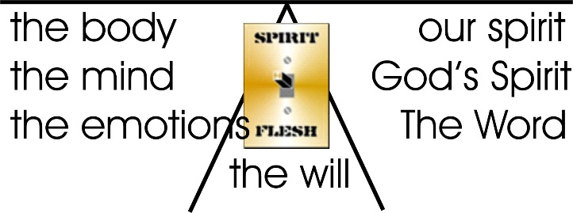

Discussion Questions

- The leader should read this scripture, then each person takes turns expressing Why was Jesus able to not sin while on earth?

For we do not have a High Priest Who cannot sympathize with our weaknesses, but was in all points tempted as we are, yet without sin. Hebrews 4:15 (NKJV)

- The leader should read this scripture, then each person takes turns expressing How does the devil get a foothold in our lives according to this scripture?

Therefore each of you must put off falsehood and speak truthfully to his neighbor, for we are all members of one body. In your anger do not sin: do not let the sun go down while you are still angry, and do not give the devil a foothold. Ephesians 4:25–27NIV

- In some cases it will require us to forgive someone if we are not to stay angry after sundown. Is forgiveness an emotion, or an act of our will?

- Does the person we are angry with have to repent in order for us to forgive them?

- The leader should read this scripture, then each person takes turns expressing How important is it to forgive according to this scripture?

For if ye forgive men their trespasses, your heavenly Father will also forgive you: But if ye forgive not men their trespasses, neither will your Father forgive your trespasses. Matthew 6:14-15 KJV

